|  |  |
| --- | --- |
|  | |
|  | **Infrax Dilbeek**  **Control description BMS**  **12/09/2017** |
|  | |
| Project | **N° 1527 – Infrax Dilbeek** |
| Noordkustlaan 10  1700 Dilbeek |
| Studiebureau | **Studiebureau Boydens** |
| Noordkustlaan 10  1700 Dilbeek |

**Table of contents**

Glossary 3

Time Schedule 4

Working system in general 4

Primary Slow reacting system 4

In Heating Mode 4

Installation Control 4

Supply Water Temperature 5

Flow Rate 5

In Cooling Mode 6

Installation Control 6

Supply Water Temperature 6

Flow Rate 7

Active cooling 7

In Rest 7

Secondary systems 8

AHU 8

Supply Air Temperature 8

Supply ventilator 8

Exhaust ventilator 8

Thermal wheel 8

Cooling Coil [LG01] 9

Heating Coil – (Free –cooling battery: loop 2 LG 32/28°C) 9

distribution control 9

To define % opening of damper by CO2 10

To define % opening of damper by Heating or Cooling demand of the zone 10

Heat exchanger cooling [E003] 17

Active cooling 17

Cooling tower 18

Working Systems in detail 19

Heat pump 19

Pump controls 19

P1 & P2 (Hydraulic pumps which supply the heat pumps) 19

P3 (Sink side loop Heat pumps) 19

P4 (Cooling H-Ex) 20

P5 (Passive cooling H-Ex) 20

P7 (TABS supply) 20

P8 (AHU heating exchanger - primary) 20

P9 (AHU heating exchanger - secondary) 20

P10 & P11 (primary and secondary of Cooling Tower heat exchanger) 20

P12 & P14 20

P13 (AHU cooling exchanger) 20

Climate Modes 21

Cooling Server Room (Klimaatkast) 23

Night Ventilation 23

Sunshading 23

Appendix 1 BKA Niveau Regeling Screen 24

Appendix 2: AHU 25

Appendix 3: TABS Cooling Logic 26

Glossary

*Treturn* temperature at the output of the heat pump evaporators (TT05)

*TbufferTank* temperature measured at the output of the water buffer tank (TT14)

*TCCA_water_supply*  (measured)water temperature of CCA supply to all circuits.

*Tsetpoint_CCA_water*calculated temperature setpoint of water supply to all circuits.

When cooling, it is limited to a minimum temperature of *TdewPt* +3.

*Theatpump_supply*water supply temperature to heat pumps. From boreholes. (TT02)

*Tsolair* measured from the outdoor temperature sensor on roof, exposed to solar radiation

*Toutdoor* continuously updated, measured outdoor temperature[1]

*Toutdoor_average Average outdoor temperature between 7h00 and 18h00, computed*[2] *and set at 18h00.*

*(static between 18h, dayn and 18h, dayn+1)*

*Tavg_outdoor_8hr* [3] moving average of 4 latest past samples of *Toutdoor* taken on the hour.

Sample rate: every 2 hr. Used to calculate *Tsetpoint_buildingBase .*

*Tsetpoint_buildingBase[4]* the base temperature of all thermostat setpoints.

Continuously calculated from *Tavg_outdoor_8hr* and a *heating* curve.

Thermostat user input (+/-) adds to this to produce a zone setpoint: *Tsetpoint_zoneX*

*Tsetpoint_zoneX* one temperature set-point of zone X: *Tsetpoint_buildingBase + user input offset*

*Tsetpoint_floor*  the (calculated) average of the zone temperature set-points (*Tsetpoint_zoneX*) on a floor

*Tsetpoint_building* the (calculated) average of all temperature set-points throughout the building

*Tindoor_average* average of 4 floor average temperatures (*Tindoor_floor ,* based on thermostat measurements)

Close to, but not exactly, the average of all thermostat measurements in the building.

*Tindoor_floor*  the average of measured temperatures at thermostats on a floor.

*VAV_ValvezoneX*refers to the VAV of a particular zone (X)

*Tsetpoint_AHU_supply_air*

*CO2.measured_zoneX*

*CO2.configured_zoneX*

# Time Schedule

*[OS Technisch lokaal – Algemeen- Onderstation algemeen]*

AHU: from 5:00 -19:00 from Monday till Friday, weekends not operative. No holidays are defined. (possibility). Outside of these hours, the operation is dependent on manual pushbutton settings on each floor.

5:00-6:00: AHU flush (AHU fully open)

TABS: 24/7 (neglect days: yes)

# Working system in general

Primary Slow reacting system: *Toutdoor_avera*ge determines climate zone of the building slow system (CCA): heating, cooling or rest mode (see chapter climate mode)

Secondary fast reacting system: based on individual zone set point temperatures (these can be checked in the BMS)

* Heat demand/cool demand: based on Tmeasured_zoneX - Tsetpoint_zoneX

If (*Tmeasured_zoneX - Tsetpoint_zoneX)* < -2.0°C: Heating.

If *(Tmeasured_zoneX - Tsetpoint_zoneX)* > 1,5°C: Cooling.

## Primary Slow reacting system

### In Heating Mode

When the Climate Mode is Heating, heating through CCA is active if:

* Heating demand based on *Tindoor_average : Tindoor_average < 22,5°C => CCA active*

While active, CCA becomes *inactive* when: *Tindoor_average ≥ 23,5°C*

Principle:

From heat pumps or buffer tank to collector to Loop 3.

#### Installation Control

In terms of installation control, this has the following consequences[5]:

1. The two-way valves on the heating circuit of loop 3 CCA are open (V.3 and V.4).
2. The two-way valves on the cooling circuit of loop 3 CCA are closed (V.5 and V.6).
3. Three-way valve (Kr3) of loop 3 CCA: modulated under PID control.
4. Pump P05 of the heat exchanger (for passive cooling) only operates during pump routine[6].
5. CCA Floor 2-way valves modulate under PID control described below.

#### Supply Water Temperature

The water temperature for the concrete core activation when heating is determined according to the following heating line:

|  |  |
| --- | --- |
| *Regelwaarde Verwarming* **Heating** | |
| *Toutdoor_average* | *Tsetpoint_CCA_water* |
| -10°C | 27°C |
| 0°C | 24,5°C |
| 15°C | 22,5°C |
|  | Min: 23°C |
|  | Max: 30°C |

This calculated setpoint is not compensated.

The CCA supply water temperature is determined by the amount of return water mixed with the supply through the 3-way valve (Kr3). This is done by modulating the 3-way valve under PID control [dead zone: 0; P:5; I: 1m00sec; D:0] applied to the difference of *Tsetpoint_CCA_water* and *TCCA_water_supply* (measured at TT24).

#### Flow Rate

The water flow rate of the CCA is controlled by means of the two-way valves placed at the end of each floor loop. Water flow rate is also calculated on a per-floor basis.

For each floor CCA circuit, using *Tsetpoint_floor, Tindoor_floor, TCCA_water_supply* and *Tmeasured,return,CCA,floorlevel,x*, the flow rate into each floor circuit is determined which in turn determines the corresponding valve settings.

First the temperature difference between the desired indoor air temperature for the floor (average of all the zone setpoints of the floor) and the measured air temperature (average of all measured temperatures at thermostats on the floor), is calculated.

Using this temperature difference (∆T1) and the following heating line, the desired temperature difference between the supply and return water (*∆T2 =TCCA_water_supply – Tsetpoint.return,CCA,floorlevelx* ) is calculated.

|  |  |
| --- | --- |
| Heating | |
| *∆T1* | *∆T2* |
| 1°C | 3°C |
| 2°C | 2°C |
| 3°C | 1°C |

*∆T2* is then used to calculate the return temperature for the floor circuit:

$$T_{setpoint, return,CCA,floorlevel_{x}}{= T}_{CCA_water_supply}-∆T_{2}$$

The opening of the valve, controlling the flow rate for every floor level, is determined by a PID [dead zone: 0.2 - P:1 – I: 30m00sec – D:0], with a minimum of 20%.

This PID is based on the difference between calculated return temperature ($T_{setpoint, return,CCA,floorlevel_{x}}$) and the measured return temperature ($T_{measured, return,CCA,floorlevel_{x}}$)

### In Cooling Mode

When the Climate Mode is Cooling, cooling through CCA is active when 2 conditions are met:

*Toutdoor_average > 16,5°C* (while this is TRUE, CCA becomes inactive when: *Toutdoor ≤ 15.5°C* )

*Tindoor_average > 24°C* (while this is TRUE, CCA becomes inactive when: *Tindoor_average ≤ 22°C* )

Principle:

Cold water delivered by heat exchanger for passive cooling [E004].

#### Installation Control

In terms of the installation control, this has the following consequences:

1. The two-way valves on the heating circuit of loop 3-CCA are closed (V.3 and V.4).
2. The two-way valves on the cooling circuit of loop 3-CCA are open (V.5 and V.6).
3. The CCA three-way valve (Kr3) is constantly 100% open.
4. Pump P05 of the heat exchanger (for passive cooling) operates under PID control, dependent on the water supply temperature (see the chapter on pumps).
5. CCA Floor 2-way valves modulate under PID control described below.

#### Supply Water Temperature

The water temperature for the concrete core activation in cooling regime is determined according to the following heating line:

|  |  |
| --- | --- |
| *(Koeling aanvoertemperatuur)* **Cooling** | |
| *Toutdoor_average* | TCCA_water_supply_curve |
| 18°C | 23° |
| 23°C | 21,5°C |
| 30°C | 20°C |
|  | Min: 19°C |
|  | Max: 23°C |

*TCCA_water_supply_curve*is compensated based on *Tsetpoint_buildingBase* and *Tindoor_average* as follows:

$if \left(T_{setpoint_buildingBase}-T_{indoor_average}\right)<0$ then *CompFactor = 0.5*

$if \left(T_{setpoint_buildingBase}-T_{indoor_average}\right)>0$ then *CompFactor = 1.5*

And:

$$T_{setpt_CCA_water}=T_{CCA_water_supply_curve} + \left(T_{setpoint_buildingBase}-T_{indoor_average}\right)*CompFactor$$

This calculated water supply temperature is then checked to see whether the supply temperature could cause condensation in the concrete. In this case there is also a compensation for the dew point. The supply temperature has to be at least 3°C higher than the dew point temperature.

$$T_{setpoint_CCA_water}=max \left(T_{setpoint_CA_water}{, T}_{dewPt}+3\right)$$

Finally, the flowrate into the passive cooling heat exchanger E004 determines the CCA supply water temperature (*TCCA_water_supply* ) during Cooling Mode. The flowrate of pump P05 into the heat exchanger (E004) is controlled by a by a PID [dead zone: 0 - P:10 – I: 45m00sec – D:0] applied to the difference of this supply temperature setpoint and the measured temperature at the outlet of the heat exchanger E004 on the water side [T17] (*Tsetpoint_CCA_water* & *TCCA_water_supply* )

#### Flow Rate

The water flow rate of the CCA is controlled by means of the two-way valves placed at the end of each floor loop. Water flow rate is calculated on a per-floor basis.

First the temperature difference between the desired indoor air temperature for the floor (average of all the zone setpoints of the floor) and the measured air temperature (average of all measured temperatures at thermostats on the floor), is calculated.

Using this temperature difference (∆T1) and the following heating line, the desired temperature difference between the return and supply water (*∆T2 = Tsetpoint.return,CCA,floorlevelx –TCCA_water_supply*) is calculated.

|  |  |
| --- | --- |
| Cooling | |
| ∆T1 | ∆T2 |
| 1°C | 3°C |
| 2°C | 2°C |
| 3°C | 1°C |

*∆T2* is then used to calculate the return temperature for the floor circuit:

$$T_{setpoint, return,CCA,floorlevel_{x}}{= T}_{CCA_water_supply}+∆T_{2}$$

The opening of the valve, which controls the flow rate for every floor level, is controlled by a PID [dead zone: 2 - P:1 – I: 30m00sec – D:0], with a minimum of 20%.

This PID is based on the difference between calculated return temperature ($T_{setpoint, return,CCA,floorlevel_{x}}$) and the measured return temperature ($T_{measured, return,CCA,floorlevel_{x}}$)

#### Active cooling

Passive/Active Switch: (TT02) *Theatpump_supply > 18°C* : Active Cooling; else: Passive Cooling.

### In Rest

When the Climate Mode is Rest, the loop concrete core activation is inactive. This implies that the valves for every floor level are 20% open (This is the minimum opening percentage).

In terms of the installation control, this has the following consequences:

1. The two-way valves on the heating circuit of loop 3-CCA are closed (V.3 and V.4).
2. The two-way valves on the cooling circuit of loop 3-CCA are closed (V.5 and V.6).
3. Three-way valve of loop CCA 3 (Kr3) is fully closed (allowing return-> supply circulation).
4. Pump P05 of the heat exchanger (for passive cooling) only operates during pump routine6.
5. CCA Floor 2-way valves are 20% open.

In the next phase, *Tsetpoint_floor* needs to be connected with the outside temperature, with the same set-point temperature used for each zone.

This has been implemented: see Appendix 1.

In a further stage we would optimize as well the control of the two-way valve (currently always on the minimum level) due to a direct connection with the outside temperature. This has been implemented: see Appendix 1.

Furthermore, the compensation on the inside room temperature is not preferable. Further optimization in the control of the CCA is required.

Not scheduled to be implemented.

## Secondary systems

### AHU

#### Supply Air Temperature

The AHU provides supply air based on the following heat curve (Tsetpoint_AHU_supply_air)

*[BMS Label: Gewenste inblaastemperatuur ]*

|  |  |
| --- | --- |
| **AHU** | |
| Toutdoor  (instantaneous) | Tsetpoint_AHU_supply_air |
| 0°C | 20°C |
| 15°C | 19°C |
|  | Min: 15°C |
|  | Max: 23°C |

During the summer, this heating curve returns a supply air temperature setpoint of approximately 18°C.

The regulation of the air supply temperature is carried out by the sequential operation of the modulation thermal wheel and the cooling and heating coil. The heating coil only operates when the required air supply temperature is not met with the intervention of the thermal wheel alone. Based on the difference between the calculated temperature of the supply air and the measured temperature of the supply air, the three-way-valve is opened of the cooling coil (LG01) or heat coil (Loop 2) and the associated pump will be activated [P9 or P13]. The pumps have an adjustable overrun time after the valves have been closed.

(see picture Appendix 2)

#### Supply ventilator

The air handling unit is equipped with variable-frequency drives and pressure sensors in the supply and the exhaust ducts. A constant pressure is created in the air ducts. The pressure level is dependent on the degree of opening of the VAV-boxes.

The speed controller [*toerenregelaar*] of the ventilator is PID-controlled and based on the difference between measured pressure in the supply duct and desired (calculated) pressure for the supply duct. [P:0.5 – I: 1m40sec – D:0]

#### Exhaust ventilator

The speed controller [*toerenregelaar*] of the ventilator is PID-controlled and based on the difference between measured pressure in the exhaust duct and desired (calculated) pressure for the exhaust duct. [P:0.5 – I: 1m40sec – D:0]

#### Thermal wheel

The **function** of the thermal wheel (heating or cooling) is based on the difference between supply (fresh) air temperature and exhaust air temperature.

if *Tmeasured, supply air –Tmeasured, exhaust air < 0* : heating

if *Tmeasured, supply air –Tmeasured, exhaust air > 0* : cooling

The decision of whether energy recovery is useful, is based on the thermal wheel function and the above temperature difference.

* The energy recovery operates as a heater when the temperature of the fresh air is 2° lower than the exhaust air.
* The energy recovery operates as a chiller when the temperature of the fresh air is 2° higher than the exhaust air.
* In case the energy recovery is not useful (none of the two conditions above), the status of the thermal wheel is at a defined minimum level

The status of the thermal wheel is controlled by a PI controller:

In case of heating: P :2 – I: 40sec (min = 0% -max =100%)

In case of cooling: P :2 – I: 40sec (min = 0% -max =100%)

#### Cooling Coil [LG01]

* Cold water delivered by Heat exchanger cooling [E003].
* Pump P13: velocity determined by the opening percentage of the 3-way valve
* The 3-way valve is regulated by a PID (P:5 –I:40sec – D: 0). The PID works on difference calculated supply temperature and measured supply temperature

#### Heating Coil – (Free –cooling battery: loop 2 LG 32/28°C)

* Water warmed up by Heat exchanger E005 [P=34kW]
* Warm water to heat exchanger coming from the collector provided by heat pumps and buffer tank [*see heat pumps*] in case pump P08 is operative
* Pump P09: velocity determined by opening percentage of the 3-way valve
* 3-way valve is regulated by PID (P:2 –I:40sec – D: 0). PID works on difference calculated supply temperature and measured supply temperature

#### distribution control

INFRAX distribution system is composed of ducts and, in several zones, VAV boxes. This means that in some zones, there are fixed flow rates, in other zones a variable flow rate is possible (VAV). In case there is a variable flow rate, the control of the flow rate of a particular zone is based on:

* CO2
* temperature of the zone (heating or cooling)

The larger of the two demands (CO2 or thermal), determines the flow rate and thus the opening of the damper. The % opening is either regulated by a PID or a fixed value defined in the BMS.

##### To define % opening of damper by CO2

Based on *∆CO2 = (CO2.measured_zoneX - CO2.configured_zoneX)*

Demand when: *∆CO2 > 20ppm* (*)

No demand anymore when: there was a demand and *∆CO2* < -20 ppm (see minimum)

% opening of the damper for air flow: PI-controller [P: 0.5 – I: 2:00m] [ *CO2 thresholds are only set in the BMS* – see Table]

Minimum opening %**:** 20% for the 1st floor and the ground floor meeting rooms

100% for the Landscape North Zone (flr 2): no CO2 regulation.

0% for all the other rooms

Maximum opening %: 100%

##### To define % opening of damper by Heating or Cooling demand of the zone

Every zone will have a heating or a cooling demand based on a *∆T.*  Depending on the zone (meeting office, landscape office, …), one of the following two *∆*T’s will be used to achieve the zone air setpoint:

*∆T* zone = *Tmeasured_zoneX - Tsetpoint_zoneX*

*OR ∆T* supply air = *Tmeasured,supply air_zoneX - T setpoint,supply air_zoneX*

In case the flow rate is fixed, the *∆T* will be only used in case there is a heating demand and to control the post heating coil.

The generic form of the switching decision is shown in the table below. See Table 1 for zone specific parameters that complete the switching specification.

|  |  |  |
| --- | --- | --- |
|  | **Off -> On** | **On -> Off** |
| **Heating** | *∆T*zone or*∆T*supply air < … | *∆T*zone or*∆T*supply air >… |
| **Cooling** | *∆T*zone or*∆T*supply air < … | *∆T*zone or*∆T*supply air >… |

The setpoint temperature will be as following:

For every zone, a correction can be defined by the user of the building to be applied to the building setpoint temperature (a function of the outdoor temperature, see Appendix 1) to produce a zone setpoint temperature. They can choose between -2° and +2° in 0.5° intervals.

*Tsetpoint_zoneX  = Tsetpoint_buildingBase  +/-* user input.

In case the supply temperature is used, the setpoint of the supply temperature will be calculated based on the difference between measured and setpoint temperatures of the zone as following:

Min supply temperature = 18°C

Maximum supply temperature = 24°C

and the PI-calculation of the supply temperature: P=0.5, I=1m40s

###### Heating Demand Case

Principle: Supply air will be heated by post heating coil. The coil receives warm water through the heat pump or buffer to Collector to Loop 1.

% damper opening (air flow): Opening of the damper is a fixed percentage, producing a fixed air flow rate, set in BMS on a per zone basis. (see table)

% of opening of the valve of the heating coil: There are two options for regulating the % of opening of the heating coil valve. That is, the PID of the heating valve can be based on either of the two *∆T’s.*

∆Tzone = Tmeasured_zoneX - Tsetpoint_zoneX

∆Tsupply air = Tmeasured,supply air_zoneX - T setpoint,supply air_zoneX

* + PID regulated by one of the two *∆T]’s (see table 1)*.
  + In case Tmeasured_zoneX drops below a defined minimum temperature, the opening % of the valve is set at maximum (100%) . The min temperature is 15°C. This 100% control is again switched to PID-control in case zone temperature is again 16°C.

###### Cooling Demand Case

Principle: air coming from the AHU (approximately 18°C) will be blown directly in the room without after-heating by the heating coil. (no zone has post-cooling: air temperature when cooling is determined by the AHU alone).

% opening of the damper for air flow:

A PID controller calculates the % opening based on one of the two following:

*∆*Tzone *= Tmeasured_zoneX - Tsetpoint_zoneX* OR

*∆Tsupply air = Tmeasured,supply air_zoneX - T setpoint,supply air_zoneX*

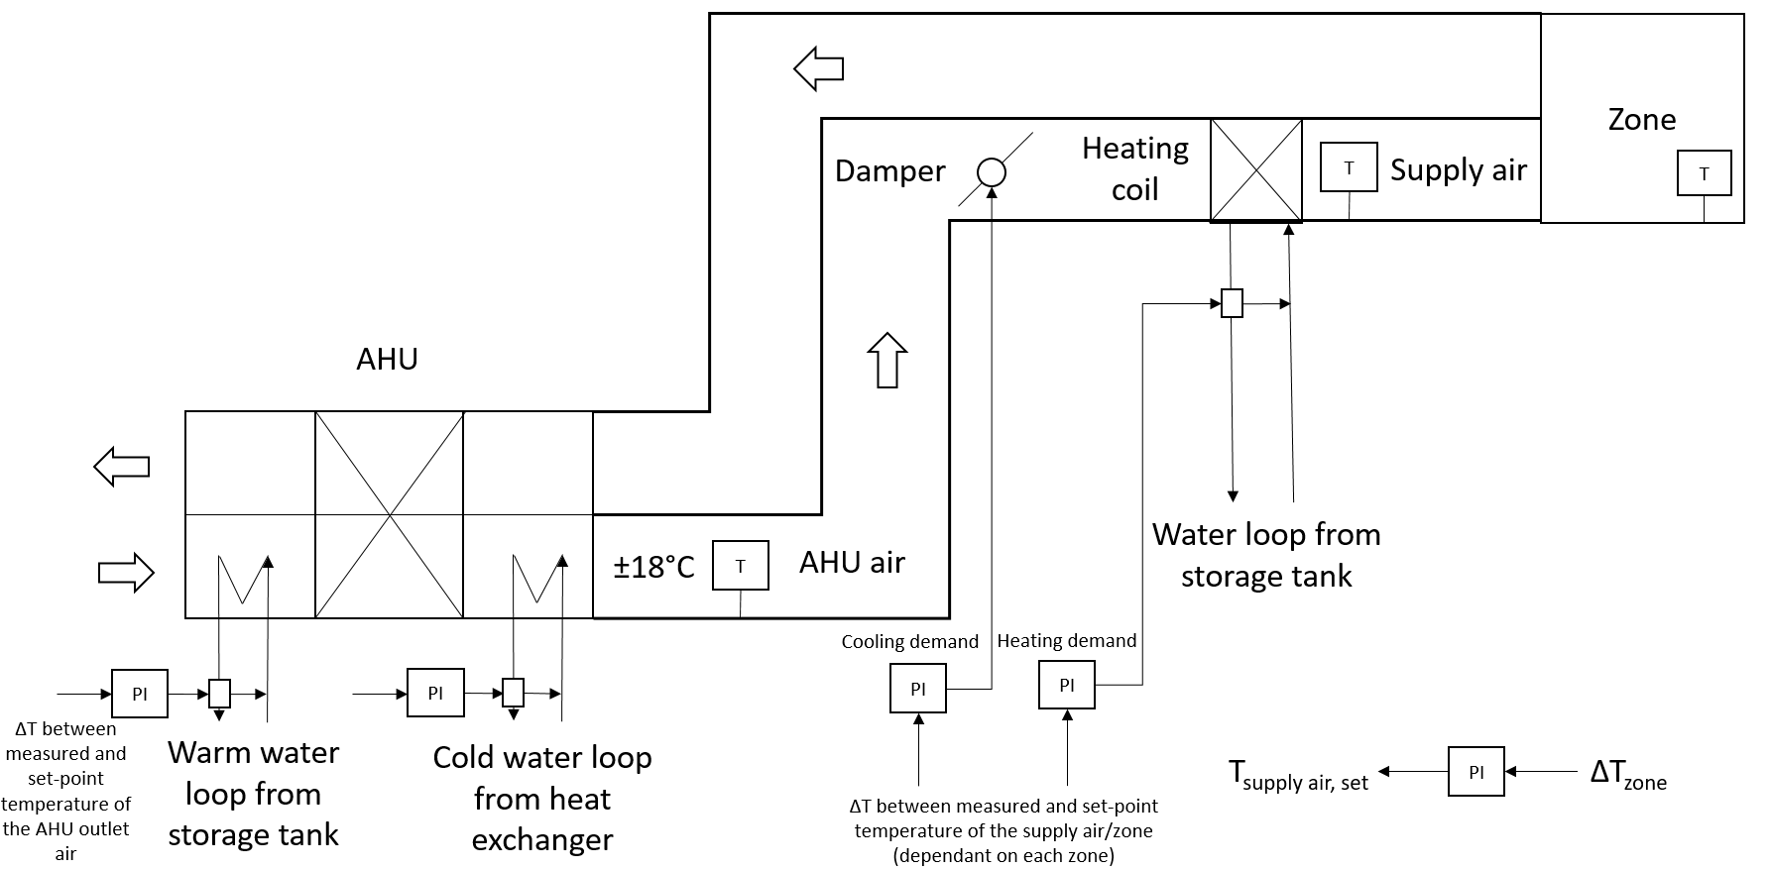

*Schematic of the Infrax Ventilation System*

|  |  |  |  |  |  |  |  |  |  |  |  |  |  |  |  |  |
| --- | --- | --- | --- | --- | --- | --- | --- | --- | --- | --- | --- | --- | --- | --- | --- | --- |
| **Room number** | **Flow rate regime (fixed or variable)** | **% Opening Damper Air (*Toevoerluchtklep: CO2,Cool: PI; Heat: Constant %*)** | | | | | **Demand Air Flow Damper** | | | | | | | **Valve heating coil** | | |
| **CO2** | **Temp controlling heating/ cooling demand** | | | | | |
| **CO2** | **Cooling** | **Heating** | **PID cooling controlled by ∆T** | | **Cooling ?** | | **Heating?** | | **Which ∆T** | | **% opening valve heating coil** | **Which ∆T** | |
| **m³/h** | **Room** | **Supply Air** | **Threshold [ppm]** | **Open: ∆T <** | **Close: ∆T >** | **Open: ∆T <** | **Close: ∆T >** | **Room** | **Supply** | **PID** | **Room** | **Supply** |
| R0.1 Hall | fixed |  |  |  |  |  |  |  |  | -1°C | 0,5°C | X |  | P:2 – I:1m40s | X |  |
| R.0.2 reception | fixed |  |  |  |  |  |  |  |  | -1°C | 0,5°C | X |  | P:2 – I:1m40s | X |  |
| R0.3 KT | VAV | P:0.5 – I:2m00s | P:0.5 – I:1m40s | 50% | X |  | 800 | 1.5 | 1.3 | -0.3 | -0.2 | X |  | P:2 – I:1m40s | X |  |
| R0.4 MT2 | VAV | P:0.5 – I:2m00s | P:0.5 – I:1m40s | 25% | X |  | 800 | 1 | -1 | -0.5 | 0.5 |  | X (PI) | P:5 – I:1m40s | X |  |
| R0.5 MT1 | VAV | P:0.5 – I:2m00s | P:0.5 – I:1m40s | 40% | X |  | 950 | 2 | -0.5 | -0.5 | 0.5 | X |  | P:5 – I:1m40s | X |  |
| R0.6 EHBO | fixed |  |  |  |  |  |  |  |  | -1°C | 0,5°C | X |  | P:2 – I:1m40s | X |  |
| R0.8 westSt | fixed |  |  |  |  |  |  |  |  | -1°C | 0,5°C | X |  | P:2 – I:1m40s | X |  |
| R0.9 eastSt | fixed |  |  |  |  |  |  |  |  | -1°C | 0,5°C | X |  | P:2 – I:1m40s | X |  |
| R1.1 SZ1 | VAV | P:0.5 – I:2m00s | P:0.5 – I:1m40s | 100% | X |  | 800 | 1.5 | 1.3 | -0.5 | 0.5 | X |  | P:10 – I:2m00s | X |  |
| R1.2 SZ2 | VAV | P:0.5 – I:2m00s | P:0.5 – I:1m40s | 25% | X |  | 800 | 1.5 | 1.3 | 0 | 1.5 | X |  | P:5 – I:1m00s | X |  |
| R1.3 MT1 | VAV | P:1 – I:2m00s | P:0.5 – I:1m40s | 5% |  | X (PI) | 800 | 1.5 | 1.3 | -2 | -1.2 |  | X (PI) | P:2 – I:1m40s |  | x(PI) |
| R1.4 MT2 | VAV | P:0.5 – I:2m00s | P:0.5 – I:1m40s | 5% |  | X (PI) | 800 | 1.5 | 1.3 | -2 | 0 |  | X (PI) | P:2 – I:1m40s |  | x(PI) |
| R1.5 NZ | Q-VAV (see picture) |  |  |  |  |  |  |  |  | -1 | 0 |  | X (PI) | P:5 – I:1m40s |  | X |
| R2.1 SZ | VAV | P:0.5 – I:2m00s | P:0.5 – I:1m40s | 20% | x |  | 500 | 1.5 | 1.3 | -1.2 | 1.3 | x |  |  | x |  |
| R2.2 MT1 | VAV | P:0.5 – I:2m00s | P:0.5 – I:1m40s | 20% |  | X (PI) | 700 | 1.5 | 1.3 | -2 | -1.2 |  | X (PI) |  |  | x(PI) |
| R2.3 MT2 | VAV | P:0.5 – I:2m00s | P:0.5 – I:1m40s | 20% |  | X (PI) | 700 | 1.5 | 1.3 | -2 | -1.2 |  | X (PI) |  |  | x(PI) |
| R2.4 NZ | See picture | Always 100% | | | | |  |  |  | -2 | -1.2 |  | X  fixed 22°C |  |  | X fixed 22°C |
| R3.1 SZ | VAV | P:0.5 – I:2m00s | P:0.5 – I:1m40s | 0% | x |  | 500 | 1.0 | 0.5 | -1 | -0.5 | x |  |  | x |  |
| R3.2 CPR | VAV | P:0.5 – I:2m00s | P:0.5 – I:1m40s | 50% | x |  | 950 | 1.5 | 1.3 | -2 | -1.2 | x |  |  | x |  |
| R3.3 SmaR | VAV | P:0.5 – I:2m00s | P:0.5 – I:1m40s | 30% | x |  | 800 | 1.5 | 1.3 | -2 | -1.2 | x |  |  | X |  |
| R3.4 MTR | fixed |  |  |  |  |  |  |  |  | -1 | -0.5 | x |  |  |  | Fixed 22°C |

***Table 1****: Technical specification of the VAV valve control on a per-zone basis.*

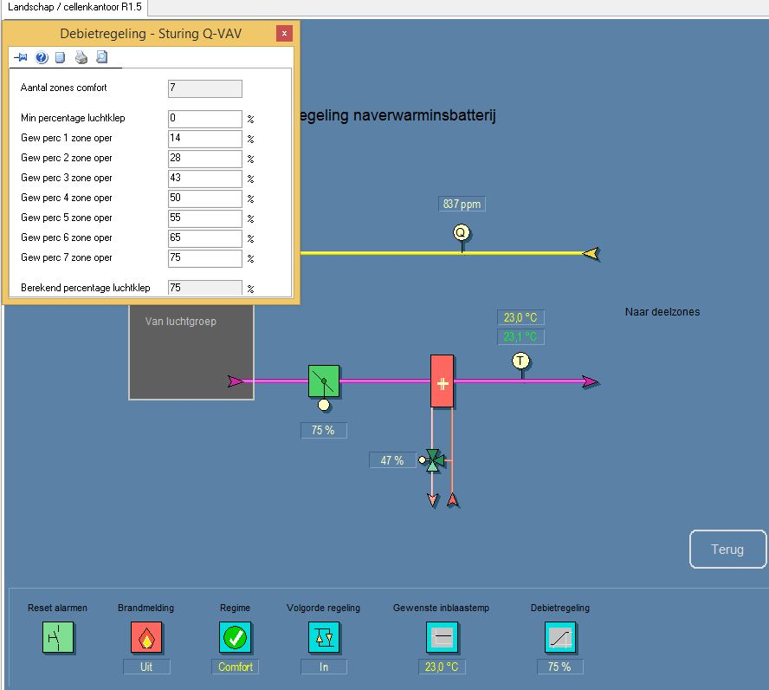

Example of air damper opening percentages based on number of vents in a zone (ZONE 1.5)

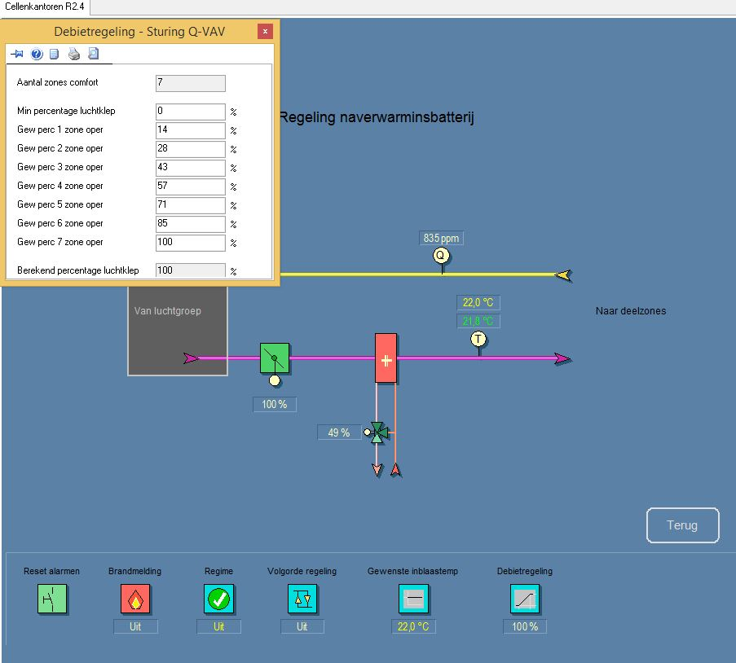

Example of air damper opening percentages based on number of vents in a zone (ZONE 2.4)

In a following stage we would like to provide an isotherm supply temperature in the room when there is no heating or cooling demand. The supply temperature out of the AHU needs to be constant 15°C, so the free cooling battery will work only if the outside temperature is lower than 15°C. The room set-point temperature needs to follow the outside temperature (moving average) instead of a fixed temperature during the whole year. Partially implemented. Isotherm part is not implemented.

### Heat exchanger cooling [E003]

Despite for the cooling cool, the HX also provides cold water for the climate chambers (server rooms?): demand regulated by blue box]. (see chapter climate rooms)

#### Active cooling

From Heat pump

Building is in cooling model:

Passive/Active Switch: If *Theatpump_supply* (TT02) *> 18°C* : Active Cooling; else: Passive Cooling.

Thereby, heat pumps start working in reverse. If buffer in tanks gets higher than 40°C , cooling tower

## Cooling tower

*[ BMS: Hoofdgebouw/Kelder/Os Technisch lokaal [2]/Kr4 koeltoren/Regimes ]*

There are 3 conditions which will control the opening of the valves V.7, V.8, V.9 and V.10 and the working of pump P10 and P11.

**Condition 1**

Heat pumps operating.

*AND Tbuffer tank* > 40°C, [7]

**Condition 2**

AND Heat pumps are operating.

AND *TbufferTank* < 38°C

AND return Water temperature to borefield (TT07) > 15°C

**Condition 3**

AND Heat pumps are NOT operating

AND *TbufferTank < 38°C* [TT14]

AND return Water temperature to borefield (TT07) > 15°C

AND Outside temperature (*Toutdoor*) minimum 5°C lower than the return water temperature to the borefield (TT07)

In case condition 1 is reached:

* V.7 and V.8 are opened
* V.9 and V.10 are closed
* Pump P10 operates permanently.
* Pump P11 operates permanently.
* The exit temperature of the cooling tower is controlled by the ventilators’ variable-frequency drive

In case condition 2 OR condition 3 is reached:

* V.7 and V.8 are closed
* V.9 and V.10 are open
* Pump P10 will only operate during pump routine6.
* Pump P11 operates permanently.
* The exit temperature of the cooling tower is controlled by the ventilators’ variable-frequency drive.

*Conditions 3*

If set point cooling somewhere in the cooling demand is not reached before 50 degree-minutes[8], the HP will start up in active cooling mode.

*When this condition is met (true):*

* Pump P10 operates permanently.
* Pump P11 operates permanently.
* Two-way valves towards heat exchanger are open.
* Two-way valves towards cooling circuit are closed.
* The exit temperature of the cooling tower is controlled by the ventilators’ variable-frequency drive

Not Implemented, No Plans

If all of conditions 1,2,3 are false:

* Pumps P10 & P11 will only operate during pump routine6.
* V.7 - V.10 are closed

# Working Systems in detail

## Heat pump

The heat pumps are working if there is a heating demand by one of the circuits (circuits 1: post-heating coils, circuits 2: Free-cooling battery AHU, circuits 3: CCA)

* The set point in the buffer tank is 32°C with a deadband of (+1 / -2°C).

When the temperature in buffer tanks gets too low (*TbufferTank*, schematic: T14), heat is provided by one of the heat pumps (E001 or E002). This is achieved with RK1 or RK2 open and RK3 closed. [Based on T19-T14: Valve controlled[9]: 0|1]

* + The mass flow rate from the boreholes is provided by one pump (either P01 or P02)

***TbufferTank* Transition**

*≥ 33*°C 1st HP ON -> OFF

≤ 30°C 1st HP OFF -> ON

* + If after 10 minutes, 1 heat pump does not succeed in bringing the buffer tank water temperature to 29*°* or above (*TbufferTank < 29°C)*, then the 2nd heat pump will be activated (*both* heat pumps will be on). The operation regime for the second heat pump is:

*≥ 31°C 2nd HP ON -> OFF*

*≤ 29°C 2nd HP OFF -> ON*

* In Cooling Mode, if TT02 > 18°C then Active Cooling is enabled, HP is ON. (rarely occurs)

## Pump controls

### P1 & P2 (Hydraulic pumps which supply the heat pumps)

* + As with heat pumps operation: either P1 or P2 is running, alternating on a weekly basis
  + When heat pumps are not running
    - RK3 valve is open, RK1 and RK2 valves are closed
    - The controller follows the following curve:

|  |  |
| --- | --- |
| **T1 – T7 [°C]** | **rpm [%]** |
| -5 | 15 |
| 0 | 40 |
| 5 | 70 |

* + When heat pumps are running:
    - RK3 valve is closed, RK1 and RK2 valves are open
    - If one heat pump is operative, P1/2 operates at 55% of nominal rpm; if two, 80%
  + P1/2 will be turned off if P4, P6 and the heat pumps are off.

### P3 (Sink side loop Heat pumps)

* + Always running under heating demand
  + When heat pumps are not running (but there is heating demand)
    - The controller follows the following curve, calculated instantaneously:

|  |  |
| --- | --- |
| **T19 – T14 [°C]** | **Head [mwc]** |
| -5 | 3 |
| 5 | 10 |

* + When heat pumps are working:
    - Pump operates at maximum head (12 mwc)

### P4 (Cooling H-Ex)

* + P4 runs under constant nominal conditions[10]. P4 is off when P12, P13 and P14 are off. P4 is on when any of P12, P13 or P14 are on.

### P5 (Passive cooling H-Ex)

* + See previous description of Supply Water Temperature for Primary Cooling.
  + Uses PI controller (parameters, P: 10, I: 45sec)
  + The controller uses a heating curve to map *Toutdoor* to *Tsetpoint_CCA_water*.
  + Compensation is applied to *Tsetpoint_CCA_water*, based on (*Tsetpoint_buildingBase* - *Tindoor_average)*
  + *Tsetpoint_CCA_water*, is then limited to 3° above dewpoint: *max* *(Tsetpoint_CCA_water, TdewPt + 3)*
  + The pump flowrate is controlled by the PID applied to the difference of *Tsetpoint_CCA_water* and *TCCA_water_supply* (measured at TT17).
  + P5 follows the operation of P7. P5 is turned off/on when P7 is turned off/on

###### P6 (VAV heating coils supply)

* + Working when VAV heating demand (always) under constant nominal conditions [on/off]

### P7 (TABS supply)

* + The pump flow rate is fixed under nominal conditions and the pump runs uninterrupted except for the following case during Cooling Mode.
  + P7 can be turned off for 2 hours during Cooling Mode if *Tindoor_average < 24°C* at (i) 00.00, 03.00 and 21.00 during weekdays or (ii) 00.00, 03.00, 06.00, 09.00, 12.00, 15.00, 18.00 and 21.00 during Sat & Sun. When these conditions are met, P7 is turned on at the end of the 2 hours.

### P8 (AHU heating exchanger - primary)

* + Working when AHU heating demand under constant nominal conditions.

### P9 (AHU heating exchanger - secondary)

* + Working when AHU heating demand under constant nominal conditions.

### P10 & P11 (primary and secondary of Cooling Tower heat exchanger)

* + Working depending on regime cooling tower under constant nominal conditions

### P12 & P14

* + Working under Blue-box (climate control system: server room) demand under constant nominal conditions. P12 & P14 operate 8 hr per day as per the cycle below.
  + Blue box demand is active on a 1 hr ON, 2 hr OFF cycle. 1hr ON periods begin at: 02.00, 05.00, 08.00, 11.00, 14.00, 17.00, 20.00 and 23.00.

### P13 (AHU cooling exchanger)

* + Working when there is a cooling demand of the zones regulated by AHU. When there is no cooling demand anymore -> delayed switch-off time (5min). under constant nominal conditions.

|  |  |
| --- | --- |
| **Coiling coil [P13]** | |
| Opening percentage 3way-valve | Calculated pump velocity [%] |
| 0 | 12 |
| 80 | 30 |
| 100 | 100 |

* + The control of the valve is regulated by PID

## Climate Modes

*[ BMS: Hoofdgebouw/Kelder/Os Technisch lokaal [2]/Warmtepompen/Rust, verw, koel ]*

The building can be in one of 3 Climate Modes:

1. *Heating* mode
2. *Rest* mode
3. *Cooling* mode

Climate Mode switching can directly occur between Heating<->Rest and between Cooling<->Rest, but not Heating<->Cooling. In order to switch between Heating<->Cooling, the building must spend at least one intermediary 24-hour period in Rest mode.

The climate mode is based on two conditions:

* The outdoor temperature
* The timers

Working of Timers

A Boolean variable (0/1) is maintained for each mode indicating whether the building is in the corresponding climate mode; at all times only 1 of these 3 variables should have a 1 value. Also, a time counter[11] is maintained for each mode indicating:

CountHEAT/ CountCOOL : time since the system climate mode changed from Heating or Cooling to Rest.

CountREST : the time the system has been in Rest mode. (only counted while in Rest mode)

The logic for maintaining these counters in terms of *possible* mode switches, is shown below:

Counter work in case:

**Mode: Value of counters Counter on/off**

HEATING CountHEAT=0 CountHEAT OFF

CountREST>= 10 hr CountREST  OFF

CountCOOL = counted CountCool  ON

COOLING CountHEAT=counted CountHEAT ON

CountCOOL=0 CountCOOL OFF

CountREST>= 10 hrCountREST OFF

REST CountHEAT=0 CountHEAT OFF

CountCOOL=0 CountCOOL OFF

CountREST=counted CountREST ON

***From*** HEAT CountHEAT ON

***From*** COOL CountCOOL ON

Determination of the climate mode (based on timers and outdoor temperature)

Under regular operation, Climate Mode Changes can occur only once per day at 18h00 (lasting a min of 24 hr). Criteria for Climate Mode switches are shown below.

***Mode IF these conditions are true [AND]:***

HEATING (i) *Toutdoor_average* < 10°C

(ii) CountCOOL  >= 20 hr5 [No Cooling mode for more than 20hours]

(iv) CountREST  >= 10 hr [Climate Mode is REST [I]]

COOLING (ii) *Toutdoor_average* > 14°C

(iii) CountHEAT  >= 10 hr

(iv) CountREST  >= 10 hr

REST if one of the above conditions is not supplied

REST (i) Climate Mode is HEATING

(ii) *Toutdoor_average* >= 10°C

REST (i) Climate Mode is COOLING

(ii) *Toutdoor_average* <= 14°C

NOTE: *Toutdoor_average*: Average Outdoor Temperature between 7h00 and 18h00[12]

The outdoor temperature is measured by two sensors: one on the north façade and one on the west façade. A weighted average of these two values is taken as the one outdoor temperature measurement6.

NOTE: Under normal operations, since Climate Mode Switches can only occur once

per day, both instances of (iii) and (iv) above are redundant (cannot be false).

At any time, the climate mode can be manually overwritten. However, this manual intervention will be automatically reset after 24h (reverted to automatic regulation).

A state diagram illustrating climate mode selection under normal conditions with state change evaluation period of 24 hr (not including override) is shown below.

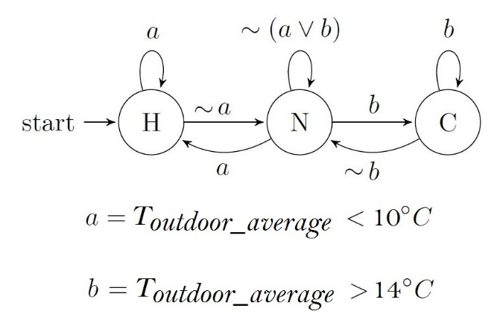

*Infrax Climate Mode State Diagram: 24 hr state change evaluation period*

# Cooling Server Room (Klimaatkast)

Klimaatkast 2 operates permanently as well as pump P14 (variable flow- ΔT regulated).

If a specific module can be added, it will be possible to control the two coolers individually; only 1 pump is controllable.

# Night Ventilation

*[ BMS: Hoofdgebouw/Kelder/Os Technisch lokaal [2]/LG 03 Kantoorgebo/Lbk bl,ww,+,- /Nachventilatie]*

Night Ventilation (NV) is ON when the following conditions are met:

1. Between 22h30 and 6h00.
2. *Toutdoor ≥ 10°C*
3. (*Tindoor_average - Toutdoor) ≥ 3*°C

(*Tindoor_average - Toutdoor) ≤ 1*°C, with NV ON, switches NV OFF

1. Night ventilation 1: *Tindoor_average* (ground floor, first floor, second floor and third floor) between 9h and 17h was over 23,5°C and stops when room temperature is under 22°C.
2. Night ventilation 2: *Tindoor_average* (ground floor, first floor, second floor and third floor) between 9h and 17h was over 22,5°C and stops when room temperature is under 21,5°C.

When the air handling unit is used for night ventilation, the unit operates with 100% outdoor air, without recuperation or cooling. During the operation of the night cooling, the average room temperature and the concrete core temperature are compared to a number of parameters every 5 minutes, after which the following actions need to take place.

The night cooling is switched off when the room temperature drops below 22°C. After the switch-off, a stabilization period of 15 minutes is held. If during this period the room temperature rises above 22,5°C again, the night ventilation will restart.

# Sunshading

On the second and third floor, a movable sunshading is provided on the east, south and west facade.

The control is based on different parameters:

1. Time
   1. East: 8h-13h
   2. South: 12h30-19h (currently, manual on for 24h)
   3. West: 15h-20h (currently, manual out)
2. *Tsolair* In: > 23°C, Out: < 21°C
3. Solar Altitude must be within:

East: (10°, 30°)

South: (20°, 22°)

West: (20°, 22°)

### Appendix 1 BKA Niveau Regeling Screen

*Tsetpoint_buildingBase* : the base temperature of all thermostat setpoints. Specific thermostat setpoints are calculated from this and user input (+/- 0 to 2°). Average floor setpoints (*Tsetpoint_floor*) are calculated from these.

Using the following line, *Tsetpoint_buildingBase* is calculated from *Tavg_outdoor_8h* , the moving average of 4 latest past samples of *Toutdoor* , sampled every 2 hr.

|  |  |
| --- | --- |
| *Setpunt ruimte temperatuur* | |
| *Voorschrijdend Gemiddelde waarde*  Tavg_outdoor_8h | *Weersafhakelijk RTset*  Tsetpoint_buildingBase |
| 20°C | 23°C |
| 24°C | 23,5°C |
| 26°C | 23,8°C |
| 28°C | 24,4°C |
| 35°C | 26°C |

The BMS screen below shows there is no user setpoint adjustments on Floor 3 while on Floor 2 the average setpoint request is -1°.

Flr 3: *Tsetpoint_floor = Average(Tsetpoint_zoneX) = Average(Tsetpoint_buildingBase + 0 {user input}) = Tsetpoint_buildingBase =* 23.7°

Flr 2: *Tsetpoint_floor = Average(Tsetpoint_zoneX) = Average(Tsetpoint_buildingBase + -1 {user input}) =* 23.7°- 1 *=* 22.7°

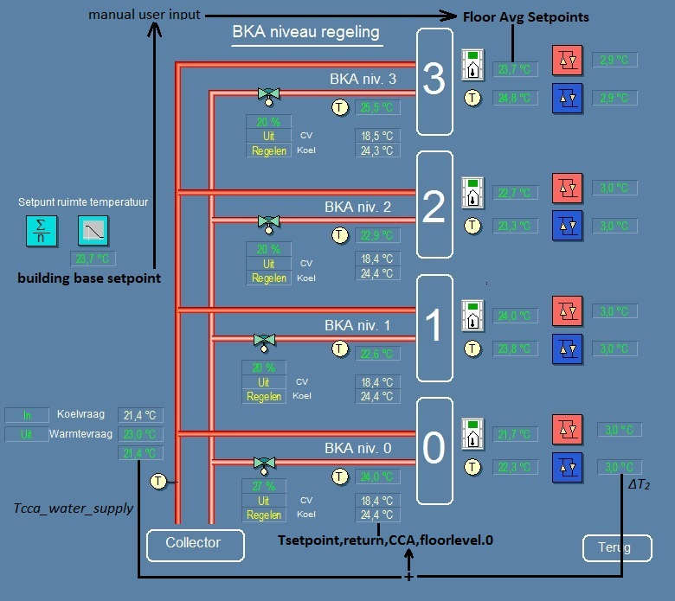

Cooling Mode: *Tsetpoint,return,CCA,floorlevel0 = TCCA_water_supply + ∆T2*

### Appendix 2: AHU

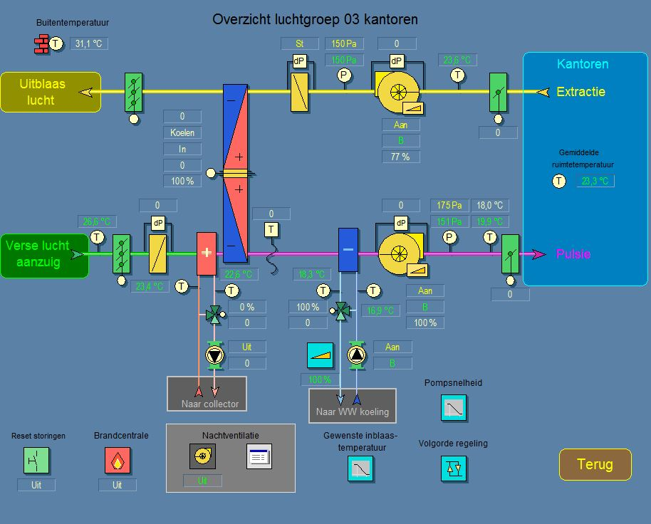

Supply vent

Exhaust vent

Thermal wheel

See loop 2

LG01

Note: Normally, the heat recovery would occur first, applied directly to the incoming outdoor air. But, a decision was made to heat up the air first, so that the fluid used to heat the air, is cooled and fed through a heat exchanger to the heat pumps, resulting in cooler return temp to the boreholes (for re-balancing)

### Appendix 3: TABS Cooling Logic

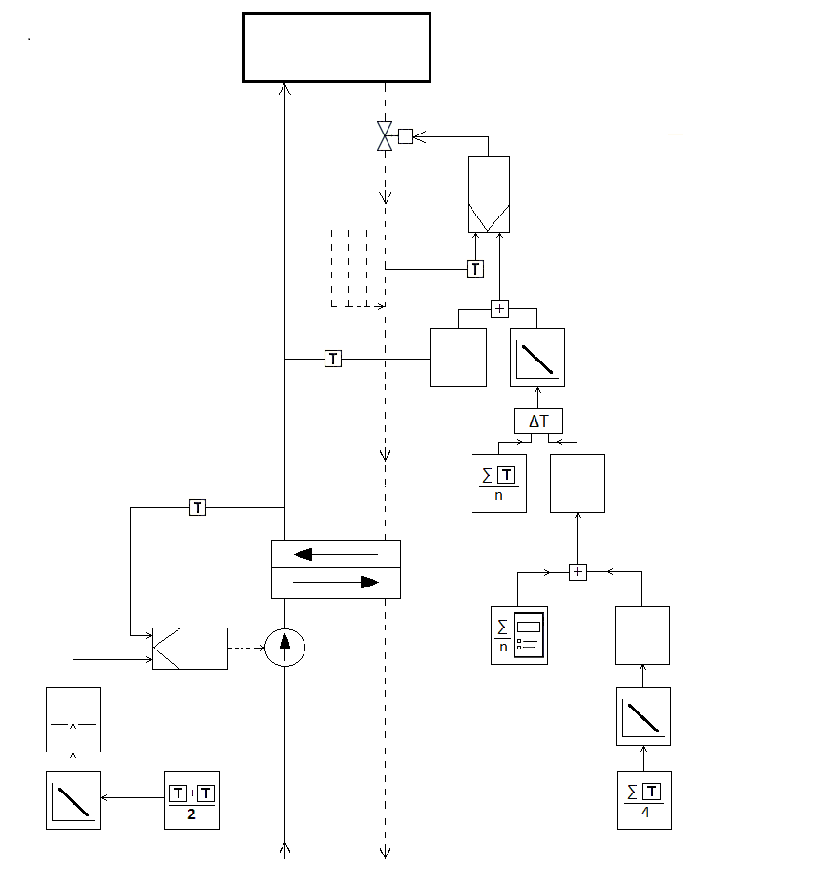

TABS Circuit

**PI**

floor returns

Return Water Setpoint

Water Heat Line

Supply Negative Slope

Temp [3, 1] => [1, 3]

Floor

Average

Setpoint

thermostats

Building

Base

supply setpoint **PI** Setpoint

flow rate user input

dew pt Heat Line

adjust positive slope

[20, 35] => [23, 26]

adapt

Moving Average

Outdoor Outdoor Temperature

Temp 4 latest samples

Sensors 2 hr sample interval

Negative Slope Weighted Average

[18, 30] => [23, 20]

Boreholes

1. One outdoor temperature measurement is a weighted average of 2 sensors: *Toutdoor = 2/3Twest.sensor + 1/3Tnorth.sensor*
2. The number of outdoor temperature values used to calculate an average depends on the sampling frequency.
3. In BMS, *BKA niveau regeling,* inside graph icon*: voorschrijdend Gemiddelde waarde*
4. In BMS, *BKA niveau regeling: Setpunt ruimtemperature*, below graph Icon (*Weersafhakelijk RTset*)
5. P7 is always ON fully; during all climate modes including heating.
6. Maintenance cycle: Wednesday,12:00-12:15
7. Temperature never reached
8. 50 degree-minutes is for example ΔT 5°C by 10 minutes, ΔT 2,5°C by 20 minutes.
9. The valve Kr3 is a new valve. In the past, the water always circulated through the condenser, whether the heat pump was operative or not. To avoid the pressure drop, a valve was installed after pump P03.
10. The software of the pump is outdated and therefore the pump cannot be controlled by the BMS.
11. Since the minimum time in a climate mode is 24 hr, these counters have no effect during regular operation.
12. The number of temperature values used to calculate an average depends on the sampling frequency. One outdoor temperature measurement is a weighted average of 2 sensors: *Toutdoor = 2/3Twest.sensor + 1/3Tnorth.sensor*.